Id | Name | Marke | Belag Art | Menge Rot | Menge Schwarz | Preis | Bild
1 | EVOLUTION MX-P | TIBHAR | Noppen-innen | 20 | 30 | 45,00 | 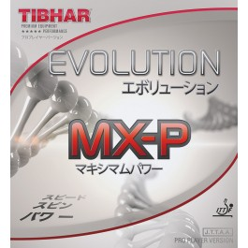
2 | EVOLUTION EL-S | TIBHAR | Noppen-innen | 20 | 50 | 45,00 | 
3 | Evolution FX-S | TIBHAR | Noppen-innen | 30 | 10 | 45,00 | 
4 | Evolution EL-P | TIBHAR | Noppen-innen | 10 | 80 | 45,00 | 
5 | Evolution FX-P | TIBHAR | Noppen-innen | 90 | 50 | 45,00 | 
6 | VARI SPIN | TIBHAR | Noppen-innen | 10 | 70 | 30,00 | 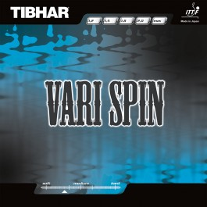
7 | Rapid | TIBHAR | Noppen-innen | 40 | 20 | 30,00 | 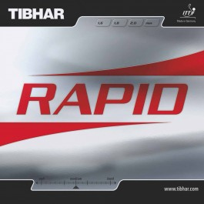
8 | Speedy Soft | TIBHAR | kurze Noppen | 20 | 60 | 35,00 | 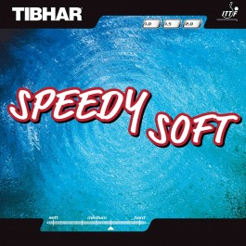
9 | Grass D-TecS | TIBHAR | lange Noppen | 80 | 70 | 35,00 | 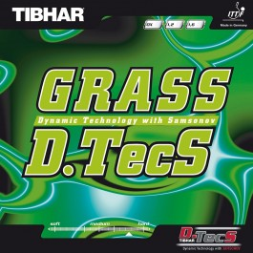
10 | Ellen | TIBHAR | Anti | 60 | 40 | 20,00 | 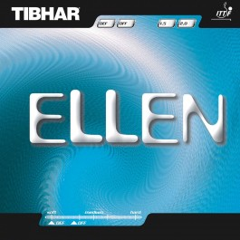

Id | Name | Marke | Belag Art | Menge Rot | Menge Schwarz | Preis | Bild
11 | Reflection | Der Materialspezialist | Anti | 20 | 30 | 60,00 | 
12 | Scandal | Der Materialspezialist | Anti | 30 | 40 | 55,00 | 
13 | Elite Long | Der Materialspezialist | lange Noppen | 70 | 20 | 35,00 | 
14 | Coppa | Donic | Noppen-innen | 20 | 40 | 30,00 | 
15 | Acuda S1 | Donic | Noppen-innen | 40 | 10 | 40,00 | 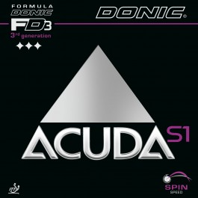
16 | Acuda S2 | Donic | Noppen-innen | 10 | 60 | 40,00 | 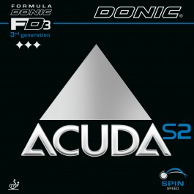
17 | Acuda S3 | Donic | Noppen-innen | 40 | 40 | 40,00 | 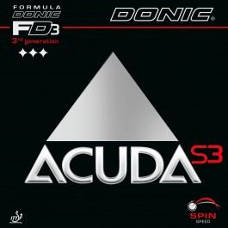
18 | Baracuda | Donic | Noppen-innen | 70 | 20 | 40,00 | 
19 | Desto F1 | Donic | Noppen-innen | 30 | 40 | 30,00 | 
20 | Liga | Donic | Noppen-innen | 90 | 40 | 15,00 | 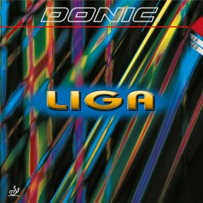

Id | Name | Marke | Belag Art | Menge Rot | Menge Schwarz | Preis | Bild
21 | Waran | SpinLord | kurze Noppen | 40 | 10 | 20,00 | 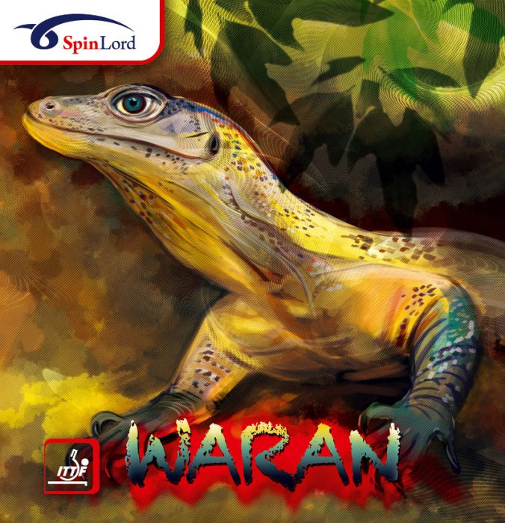
22 | Keiler | SpinLord | Kurze Noppen | 30 | 30 | 20,00 | 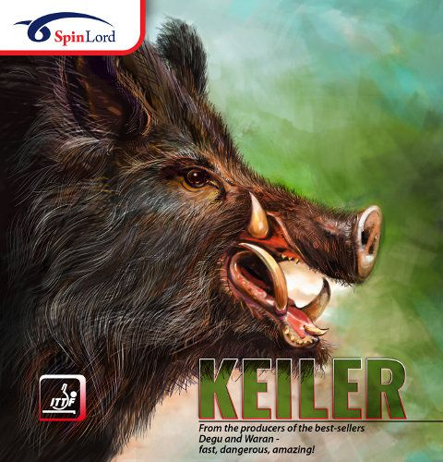
23 | Degu | SpinLord | kurze Noppen | 70 | 40 | 25,00 | 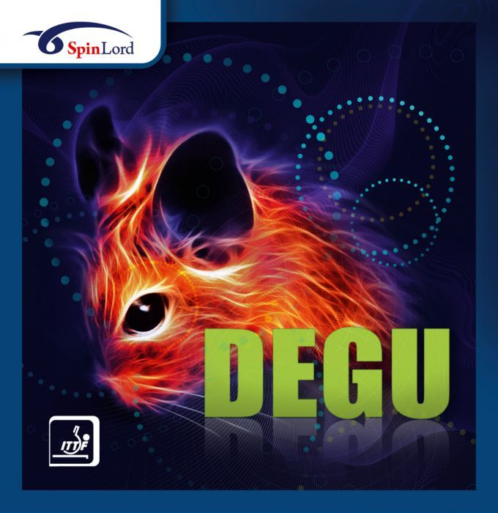
24 | Feuerstich | SpinLord | lange Noppen | 10 | 20 | 15,00 | 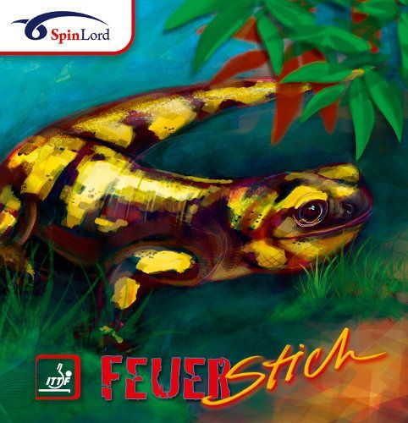
25 | Gigant | SpinLord | Anti | 20 | 20 | 15,00 | 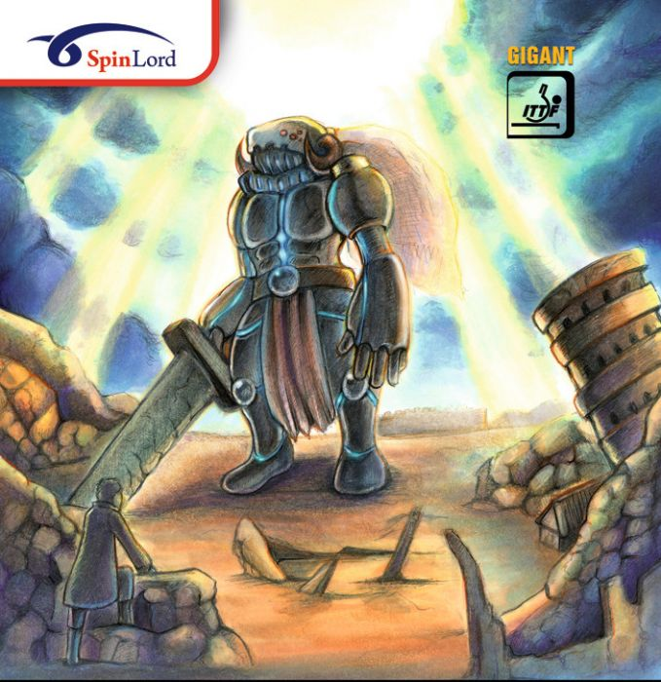
26 | RITC | Friendship 729 | Noppen-innen | 30 | 20 | 10,00 | 
27 | Geospin | Friendship 729 | Noppen-innen | 50 | 10 | 5,00 | 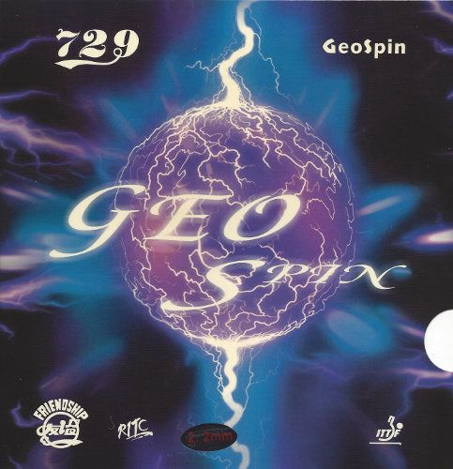
28 | Bloom Spin | Friendship 729 | Noppen-innen | 70 | 20 | 25,00 | 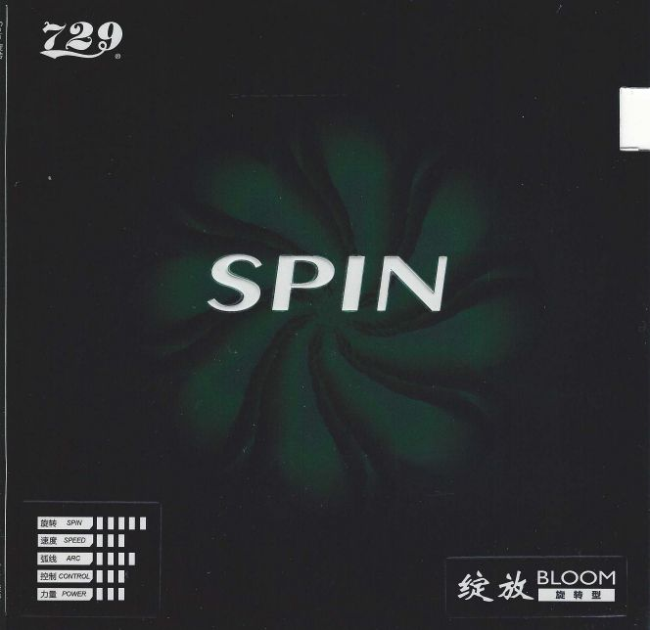
29 | Focus 2 | Friendship 729 | Noppen-innen | 20 | 50 | 15,00 | 
30 | Bloom Power | Friendship 729 | Noppen-innen | 90 | 10 | 25,00 | 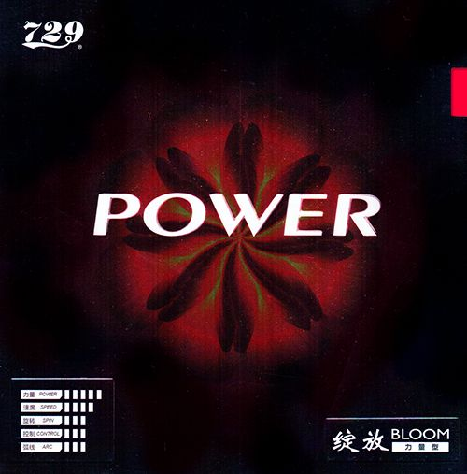

Id | Name | Marke | Belag Art | Menge Rot | Menge Schwarz | Preis | Bild
31 | Aggressor | Lion | Noppen-innen | 20 | 30 | 5,00 | 
32 | Roar | Lion | Noppen-innen | 30 | 10 | 20,00 | 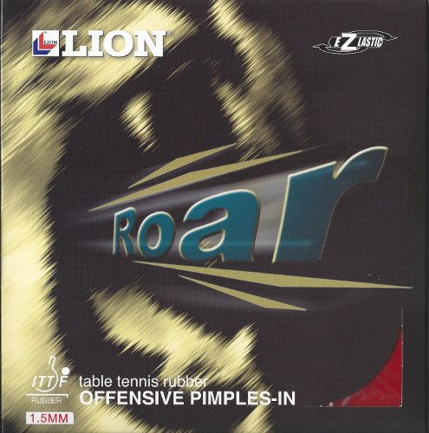
33 | Mantlet | Lion | Anti | 40 | 20 | 15,00 | 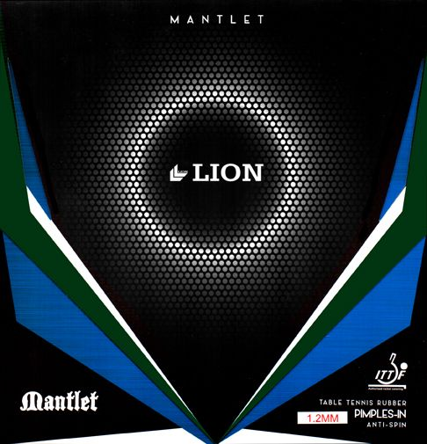
34 | Amigo | Palio | Noppen-innen | 40 | 40 | 15,00 | 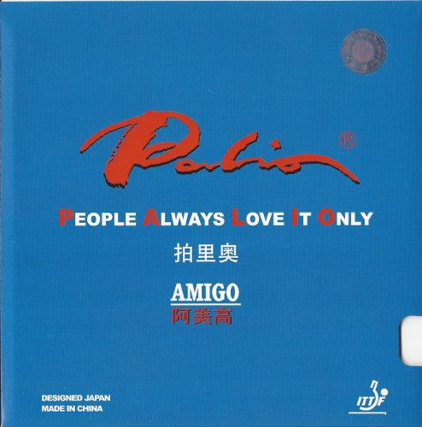
35 | Conqueror | Palio | Noppen-innen | 90 | 20 | 10,00 | 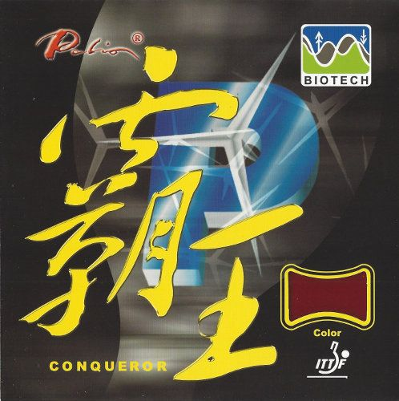
36 | AK 47 blue | Palio | Noppen-innen | 40 | 60 | 20,00 | 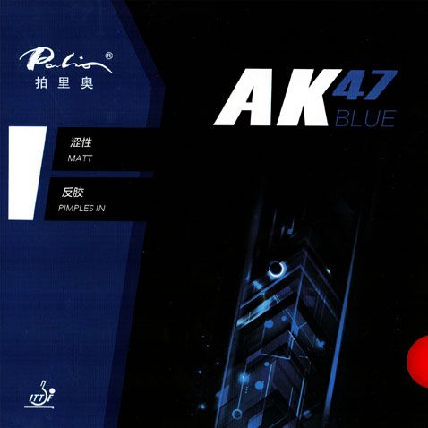
37 | AK 47 red | Palio | Noppen-innen | 60 | 40 | 20,00 | 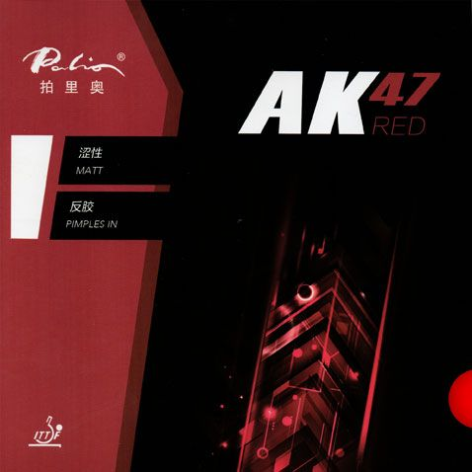
38 | AK 47 yellow | Palio | Noppen-innen | 50 | 50 | 20,00 | 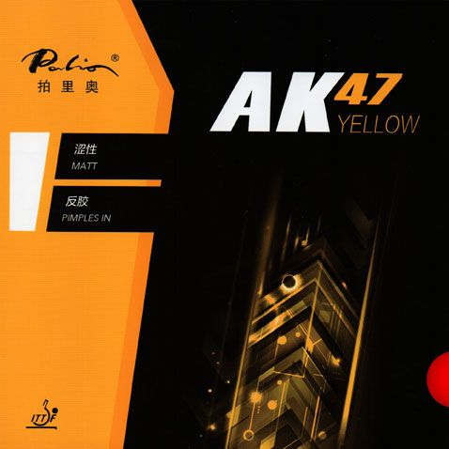
39 | Peril Anti | Giant Dragon | Anti | 40 | 20 | 20,00 | 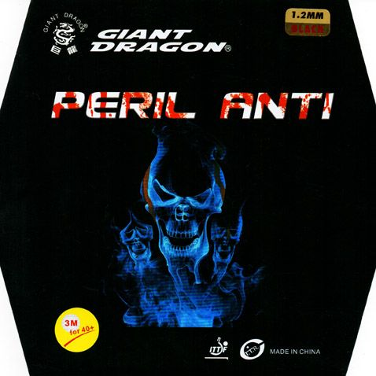
40 | Cropcircles | Giant Dragon | lange Noppen | 90 | 10 | 15,00 | 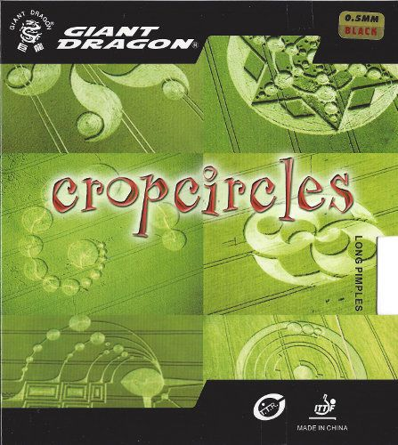

Id | Vorname | Nachname | Passwort
1 | Max | Musterman | Muster1234
2 | Leon | Profie | Katze01Ki0
3 | Michael | Mühlbach | TTMM002010
4 | Andreas | Mühle | Hi1408MA00
5 | Lukas | Becker | 33wwe1900A
6 | David | Kern | 09qwer1234
7 | Paul | Paulchen | ASDF1234MN

Bilder Beläge

https://www.tt-shop.de
https://ttdd.eu

Bilder Seite

https://image.jimcdn.com/app/cms/image/transf/none/path/s38cff5e4a4fd091a/backgroundarea/i01b7d088df14327a/version/1572780516/image.jpg

https://usercontent.one/wp/www.svc-belm-powe.de/wp-content/uploads/2020/09/TT-Schl%C3%A4ger.jpg

https://www.google.com/url?sa=i&url=http%3A%2F%2Fttbl.de%2F&psig=AOvVaw0QoffiBeeMMZUj-I-SihVl&ust=1620660308578000&source=images&cd=vfe&ved=0CAMQjB1qFwoTCLil26H0vPACFQAAAAAdAAAAABAD

https://www.google.com/url?sa=i&url=https%3A%2F%2Fwww.facebook.com%2FTTCNeuweiler%2F&psig=AOvVaw0l-Vmo6MTUGdWnyrSsmOYo&ust=1620660736144000&source=images&cd=vfe&ved=0CA0QjhxqFwoTCNiMxfH1vPACFQAAAAAdAAAAABAD

https://www.google.com/url?sa=i&url=http%3A%2F%2Fwww.ttc-altenwald.de%2Findex.php%3Fstart%3D51&psig=AOvVaw1xbDZXgIDYNlIzbPLWJwXt&ust=1620660981576000&source=images&cd=vfe&ved=0CAMQjB1qFwoTCJiS_OL2vPACFQAAAAAdAAAAABAD

